Swaziland National HIV/AIDS Programme

SNAP’s mandate is to take the leadership role in HIV/AIDS health sector response. The health sector response covers a number of thematic areas.
Anti-retroviral therapy (ART)
The National ART Programme was established as a unit in 2003 under the Swaziland National AIDS Programme (SNAP) of the Ministry of Health. The priority intervention of the ART unit is the provision of high quality treatment and care for all adults, adolescents and children living with HIV/AIDS in the Kingdom of Swaziland through the provision of Anti-retroviral therapy (ART) and related services.
For the ART unit to meet its targets, the under-listed activities were embarked on during the reporting period:
i) HIV Care Decentralization: It refers to the planned, systematic and targeted roll out of quality HIV/TB services to populations that need them the most. In our setting, these populations often reside in rural and remote settings where transportations may limit access due to unfriendly terrains and scarcity of vehicles. Decentralization of HIV and TB services has been made possible by the deployment of new technologies such as point of care CD4 machines, establishment of mini labs in some clinics and establishment of the National Sample Transportation System. Decentralization of HIV and TB services has been made possible through the collaborative work between SNAP and partners such as MSF in the Shiselweni Region, CHAI and PEPFAR partners such as ICAP, URC, EGPAF AND PSI.

ii) The NARTIS: Nurse-led ART Initiation in Swaziland is another innovative intervention embarked on by the ART unit whereby qualified Registered Nurses are provided with special training and skills to equip them with necessary competences to enable them evaluate HIV infected individuals and initiate eligible ones on appropriate ART combination regimen. Training of Registered Nurses in ART initiation helps to improve accessibility of ART services for people in the rural areas, who attend clinics that are run only by nurses. This then reduces the need for the patient to travel to hospital and wait for the doctor to initiate ART, and also saves time and cost for the patient.

iii) Trainings:The ART unit of SNAP ensures that nurses and clinician engaged in HIV/AIDS/TB care provide high quality care at all times through regular in-service training of program staff. The trainings are of varying degrees based on cadre of staff and scope of practice. They include Basic IMAI (Integrated Management of Adult and Adolescent Illnesses) for Nurses; Advanced IMAI for Physician; and NARTIS training for ART-initiating Nurses. These trainings have been made possible through the technical and financial assistance of PEPFAR Partners (ICAP, URC, EGPAF, PSI) and other partners such as MSF in the Shiselweni Region.

Regional Mentoring Teams: In order to ensure delivery of quality HIV and TB services, PEPFAR partners have supported the MOH with establishment of Regional Mentoring Teams, composed of experienced health workers (Doctors and nurses). The teams are available in the Lubombo, Manzini and Hhohho Regions and conduct frequent visits to the health facilities in the regions to provide support and on-site trainings for health care workers providing HIV and TB services. These teams ensure that quality of services being provided is improved.

The Max-ART Project:This is a collaborative project between the SNAP of the Ministry of Health and a consortium of partners that include Stop AIDS Now!; Clinton Health Access Initiative; SAfAIDS; University of Amsterdam among others. Max-ART involves a collection of interventions and activities aimed at maximising HIV counselling and testing, early enrolment in HIV care and ARV initiation, reaching and enrolling in care some hard-to-reach groups like men and adolescents, and interventions aimed at high retention in HIV-care in general, and Anti-retroviraltherapy in particular. In this project, ambitious targets have been set for achievement, a move aimed at further accelerating the current interventions within the National ART Programme.

iv) Operational Researches:to evaluate quality of provided care and service, to investigate the extent to which program objectives and targets are met, and to generate information needed for planning and programming, the ART unit is frequently engaged in both routine surveys and operational researches. Two studies were completed this year, which include the ART Outcomes Study and the ART Costing Study.

v)Collaborative Activities (TB/HIV; FP/HIV; Partners):work together with other units, programs and partners, the ART unit tries to maximize services provided to clients through service integration. In this line, the unit works in collaboration with the National TB Program and the Sexual and Reproductive Health unit, respectively, to provide TB treatment and Family Planning services together with ARVs to clients needing a combination of these services. This eliminates multiple clinic visits by clients.
Achievements
The programme was able to realize the following achievements by the year ending, 2012:
- Total number of eligible patients enrolled on ART increased from 72,402 in December 2011 to 87,534 by December 2012 with ART coverage among eligible clients standing at 90%.

Table 2.2.a:Total Number of people on ART by Region by end of 2012

Region | Category | Quarter 1 | Quarter 2 | Quarter 3 | Quarter 4
Hhohho | Adults (15+) | 20628 | 20858 | 21316 | 22296
Hhohho | Children(0-14) | 2289 | 2335 | 2371 | 2409
Lubombo | Adults (15+) | 12433 | 12771 | 13497 | 14049
Lubombo | Children(0-14) | 1503 | 1533 | 1545 | 1590
Manzini | Adults (15+) | 24437 | 25799 | 27237 | 29058
Manzini | Children(0-14) | 1977 | 2031 | 2121 | 2185
Shiselweni | Adults (15+) | 13211 | 13771 | 13905 | 14700
Shiselweni | Children(0-14) | 1157 | 1182 | 1180 | 1247
Sub Total | Adults (15+) | 70709 | 73199 | 75955 | 80103
Sub Total | Children(0-14) | 6926 | 7081 | 7217 | 7431
Grand Total |  | 77635 | 80280 | 83172 | 87534

- A total of 5,438 new adult and paediatric patients were enrolled on ART by December 2012.
- Total number of health facilities providing ART initiation and refills increased to 125 sites in 2012
- Strengthened integration with the Sexual and Reproductive Health (SRH) program through development of SOP for FP/HIV-care integration, and integration of Family Planning (FP) services in 1 ART Health facility in 2012.
- Increased the proportion of co-infected (TB/HIV) patients initiated on both TB and ARVtherapies from 51% to 71% by September 2012.

Furthermore, the following operational researches were completed by 2012:
- Clinical & Immunological Outcomes among Adults enrolled on ART, 2004-2010.
- Clinical & Immunological Outcomes among Pediatrics enrolled on ART, 2004-2010.
- Cost of providing chronic care among Adult and Pediatric patients enrolled in HIV care in Swaziland.
Challenges
The main challenge faced by the ART unit during the review period was the limited stock of reagents for CD4 testing and blood chemistry during the first and second quarter of 2012. This impacted adversely on ART enrolment figures during the affected periods. The situation has gradually normalized and ART enrolment has since picked up again.

HIV Testing and Counselling (HTC)
HIV Testing and Counselling (HTC) services have been dramatically expanded in the country since the inception of the HTC program in 2003. Since 2006, HTC services have been following a dual approach to reach the widest range of people: Client-initiated HTC and Provider-initiated HTC. HTC has been identified as the entry point for HIV Prevention, treatment, care and support in Swaziland. HTC is viewed as an approach to empower individuals to make informed choices and decisions in seeking early health care services.

Table 2.2b: Number of People Tested in 2012 by Region
REGION | TOTAL NUMBER TESTED
Hhohho | 62256
Manzini | 81498
Lubombo | 41086
Shiselweni | 36993
Unknown | 423
GRAND TOTAL | 222256
Source: HMIS 2012
The table shows the number of tests done in 2012 by region, Manzini region shows the highest number of tests archived. Of note this year the Programme was able to reach its yearly target of 196,000 tests. This was attributed to the scale up of HTC in Health facilities. More lay counsellors were placed in high volume areas especially the Outpatient areas, thus we have been able to achieve out HTC Target. Again the programme started a process of orienting Nurses on PIHTC SOPS and this has good results as more nurses were now offering HTC to most of our clients.
Figure 2.4: No. of Tests By Gender
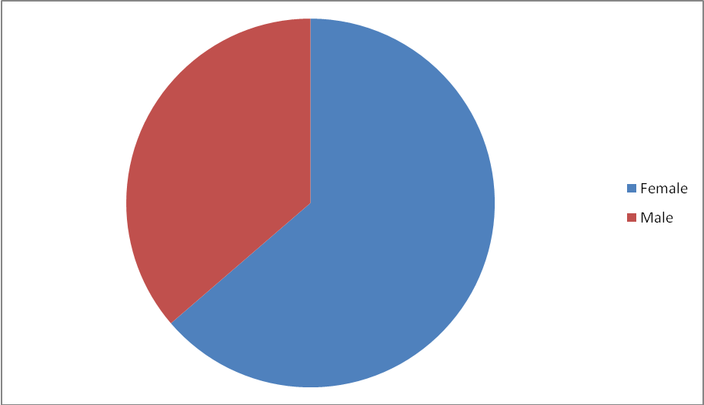
Source: HMIS 2012
Females continue to be the highest in knowing their HIV Status (141196) as compared to males (80511). There is a great improvement in the uptake of HTC by males. The programme has started to use innovative strategies for male testing e,g Fast –Track, Campaigns targeting males and MC.

Figure 2.5: HTC Uptake by Age Group
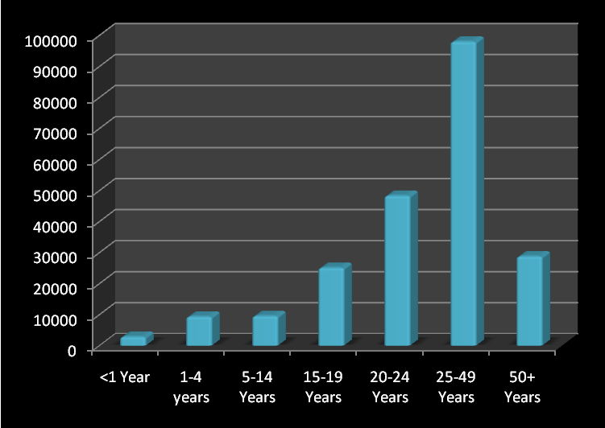

The table above shows the number of tests by age group. The age group 25-49 shows the highest figure. It is exciting as this is the sexually active group and Prevention of HIV is key to this group. Adolescent testing remains low, but the programme has started some strategies for adolescent testing and nurses have been trained on counselling adolescents

Figure 2.6: Newly Diagnosed HIV Positive
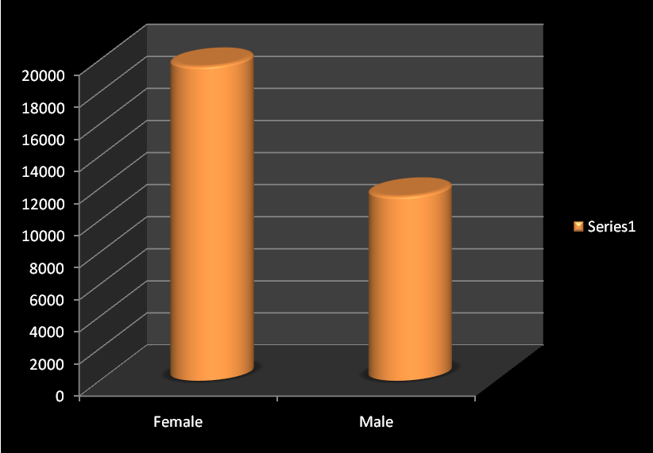
Illustrated in the figure above is the number of people that were diagnosed HIV positive during the reporting period. This figure measures the positivity rates nationally. A total of 31,169 people were newly diagnosed HIV positive from the start of the reporting period to date. According to the national indicator, it is expected that people tested also know their HIV results. Knowing one's results increases the chances of seeking proper interventions. For those whose results are positive, expectations are that a CD4 count should be taken to ascertain ART eligibility and positive living and for those whose HIV status is negative, expectations centre around staying negative.
There were a number of challenges that were experienced during the reporting period. One of them was the shortage of personnel for clinical Mentoring and Site Support supervision. Also some data capturing tools do not include HTC (Outpatient and Inpatient Registers).
Voluntary Medical Circumcision
Safe medical male circumcision (MC) reduces the risk of heterosexual transmission of HIV from a female to a male by up to 60%. MC is offered as part of a comprehensive HIV prevention strategy especially in countries with a high HIV prevalence and a low prevalence of MC like Swaziland. The faster the scale-up of MC services, the better the benefit.
The main strategy for offering MC services is integration of MC services in the Public and Private Hospitals, Health Centres, Fixed and Mobile NGO sites and outreach models. MC was offered using the above approaches with a significant amount of success.
Table 2.3: The National MC targets for 2012
National Target | Achievement
10 000 adults | 9,977
3 500 neonates | 1,231
TOTAL | 11,208
As a way to scale up safe medical male circumcision services among the school going boys and men in Swaziland a BACK TO SCHOOL (BTS) campaign was conducted. A total of 19 sites were utilized. All clients counseled offered and encouraged to test for HIV before MC. Informed consent obtained from parents for minors. Site readiness and quality assurance activities were done by MOH national QA team. WHO surgical MC approved methods were used. Hygiene packs were given to clients post-surgery with soap and towel to ensure hygiene during healing. 24 Hour Emergency Availability for Adverse Events. Clients followed up on day 2 and day 7 with transport arranged for both follow ups. 5,742 MC’s were done in a total of 6 weeks, this represents 61.5% of all MC’s needed to achieve the annual target of 10, 000.
Furthermore, EIMC services are provided by nurses, under the supervision of a doctor. This means that services can only be provided in sites where there is a doctor, which for Swaziland means 11 facilities (5 hospitals and 6 health centres). To date, EIMC services have been integrated in 13 facilities, 10 public (Mbabane Government Hospital, Piggs Peak Government Hospital, Hlathikhulu Government Hospital, Mankayane Government Hospital, Mkhuzweni Health Centre, Nhlangano Health Centre, Dvokolwako Health Centre, Sithobela Health Centre, Matsanjeni Health Centre and RFM Hospital) 2 private (Medisun Clinic and the Women and Children’s Hospital) and 1 NGO (FLAS Mbabane Clinic), and are available on a daily basis. EIMC services have expanded beyond the public health facilities to include private hospitals and the expansion to private facilities has been successful and was met with enthusiasm from the private facilities.
Good Shepherd Hospital remains the only public hospital which has not fully integrated EIMC services in their maternal and child health services. Meetings have been held with the management to discuss integrating the services. There were challenges with a suitable space to provide the service; a clinic in a box is being procured for MC services in the hospital. Services are expected to start in April 2013.
PSI continues to build capacity of health care works on EIMC. Since the integration of the programme in 2011, 11 skills trainings have been conducted with 24 doctors and 62 nurses trained and certified competent. A training of trainers has been conducted and 5 proficient EIMC providers were trained as skills trainers. However due to the dynamics of the service which include demand and consent, some participants do not reach competency within the scheduled training days, and need to be followed up in their facilities.
Mentorship and Support supervision are vital to competency based training so that participants are able to reach competency and perform the procedure efficiently. Health workers’ who are deemed not competent by the end of the training are provided with a one-on-one, facility-based mentorship by the training facilitator until the health workers can demonstrate competency. Fortnightly support supervision visits to the facilities to provide technical support and ensure adherence to the protocol and delivery of quality EIMC services, and to also ensure an increase in the uptake of EIMC are conducted.
With the support of JHPIEGO, EIMC quality assurance standards have been developed. These tools have been developed in collaboration with WHO and approved by the national MC Task Force and are in-line with JHPIEGO’S signature standards-based protocols which use objective and measurable performance standards to monitor and improve the quality of services.
SNAP with its main MC implementation partner PSI, worked with EGPAF to ensure that EIMC is integrated into national tools, PMTCT trainings and male involvement through male focused health day activities at community levels. The national tools that have integrated EIMC indicators include the child health card, ANC register, and postnatal register and ANC card. EIMC has also been integrated into the following PMTCT HTC job aids as a means of creating demand for EIMC for pregnant women who might give birth to male children: ANC pre-test flip chart; ANC post-test flip chart; and Maternity HTC flip chart, which are used by nurses at different entry points.
Although services are ongoing, the primary challenge is doctors’ availability, as they are often pulled in many directions to attend to other hospital emergencies and competing needs. The National MC Policy states that the early infant circumcision surgical procedure can be task shifted to nurses, and Swaziland recently finalized a draft National Task Shifting Policy which assigns early infant circumcision to the general nurse cadre.
An evaluation of the acceptability and Safety of the PrePex™ Device for Adult Male Circumcision in Swaziland was carried out in in two clinical sites as a pilot study. The study protocol was completed in 2012, will be submitted to the ethics committee for approval shortly.
SNAP continues to formulate strategies that target the Most at Risk Populations (MARPS). One of the programme objectives that are pursued by the programme is the strengthening of the coordination for MARPS. Already TORs for the MARPs Technical Working Group have been developed. Other programme objectives are Create a conducive environment that enhances Universal Access to prevention, treatment, care and support for key populations and to promote positive health seeking behaviour.
Table 2.4.: Male condoms, Female condoms and Lubes among MARPs
Month | Male condoms | Female condoms | Lubes
Jan | 2776 | 35 | 587
Feb | 3222 | 72 | 583
Mar | 2545 | 86 | 583
Apr | 3150 | 45 | 583
May | 2653 | 67 | 583
Jun | 2555 | 55 | 583
Jul | 2805 | 84 | 583
Aug | 2646 | 102 | 583
Sep | 2545 | 96 | 583
Oct | 1700 | 84 | 583
Nov | 1500 | 90 | 583
Dec | 1902 | 35 | 583
Total | 29999 | 851 | 7000

Palliative Care
Palliative care seeks to improve the quality of life of people and their families suffering from life limiting illness. In Swaziland the need for palliative care services is immerse due to HIV/AIDS as the the prevalence is 26%. Non communicable diseases
(NCDs) also contributes to the immerse need for palliative care in the country. Through SNAP, the MOH is integrating palliative care services into the health system in a bid to increase access to care for people with chronic incurable illnesses. To this end, several initiatives have been undertaken which include the development of the palliative care guiding documents such as the policy, strategic plan and the guidelines
As a way to build capacity, to date 206 health care workers have attended a series of introduction to palliative care workshops in the following three regions; Manzini, Lubombo, Shiselweni. It is worth mentioning that palliative care trainings are conducted in teams as it is a principle that palliative care services are delivered in a team approach. A number of challenges were faced by the programme like that it is heavily donor dependent

Table 2.5: Number of People Reached Through Community / Home Based Care
NAME OF PARTNER | # OF PEOPLE REACHED THROUGH
NAME OF PARTNER | CBVs TRAINED | COMMUNITY ACTIVITIES (Door-to-Door home visits) | TARGETS OF PEOPLE TO BE TRAINED/REACHED | AREAS TO BE COVERED
TASC | 52 | 1442 | 200 | Lushikishini, Kudzeni, Nkamanzi, &Luhlokohla
WOMEN & LAW SA | 63 | 868 | 100 | Gamula, Sicelwini, Ndlovunga&Phonjwane
AMICAALL | 108 | 495 | 200 | Lavumisa, Matsapha, Manzini, Siteki, Ezulwini, Piggs Peak, Nhlangano, Hlathikhulu, Ngwenya, &Mankayane
MoH | 2078 | 11218 | 4000 | All Chiefdoms
SWAPOL | 25 | 257 | 250 | Siyendle, Nsangwini, Sibovu, Bhahwini, Mgomfelweni, Ngomane, Mambatfweni, &Ntfunguye
ACTS OF FAITH | 83 | 1367 | 100 | ZombodzeInkhundla, Sigombeni, Manzini North, NgwempisiInkhundla, Mahlanya, Emkhiweni, Sigangeni, Enyakeni, Velezizweni, &Mbekelweni
Positive Women Together | 35 | 716 | 150 | Dvokolwako, Ngwempisi,
THE CHURCH FORUM | 148 |  | 300 | All Chiefdoms in Mahlangatsha
SHISELWENI CHURCH REFORM | 850 | 6200 | 850 | Bambitje, Dwaleni, Engololweni, Esibovu, Etjeni, Madulini, Nsingizini, Qomntaba, Shiselweni 1, Somntongo, Bulawayo

